SCHOOL OF COMPUTER SCIENCE AND ARTIFICIAL INTELLIGENCE |  |  | DEPARTMENT OF COMPUTER SCIENCE ENGINEERING
Program Name: M. Tech/MCA |  | Assignment Type: Lab |  |  | AcademicYear:2025-2026
Course Coordinator Name |  | Venkataramana Veeramsetty
Course Code | 24CS002PC215 | Course Title |  | AI Assisted Problem Solving Using Python
Year/Sem | I/I | Regulation |  | R24
Date and Day  of Assignment | Week1 - Tuesday | Time(s)
Duration | 2 Hours | Applicable to  Batches |  | M. Tech/MCA
AssignmentNumber:03.3(Present assignment number)/24(Total number of assignments)
NAME : RIMSHA MUJEEB
ROLLNO : 2503B05138
BATCH : M.Tech(CSE)

TASK DESCRIPTION

Application for TGNPDCL:
Objective: Build an application using the Python program for TGNPDCL, to generate the bill based on energy consumption and type of customer with the help of AI tools. Build a python application as per below instructions
• Read all the required data like PU,CU and Type of customer
• Calculate bill amount based on number of units consumed, type of customer
and other charges
• Finally print the values of EC(Energy Charges),FC(Fixed
Charges),CC(Customer Charges),ED(Electricity Duty Charges),bill as per
expected output
Requirements:
• VS Code with GitHub Copilot or Google Colab with Gemini
• Students should bring power bill from their home
Deliverables:
• Print energy bill for given inputs and verify with bill taken by students

PROMPTS:

1) Generate the complete Python code for this electricity bill calculator.
2) Add detailed bill printing format and include customer name input.
3) Print EC, FC, CC, ED, and Total Bill neatly for the entered inputs.
4) Print Clear Bill Summary.

CODE:
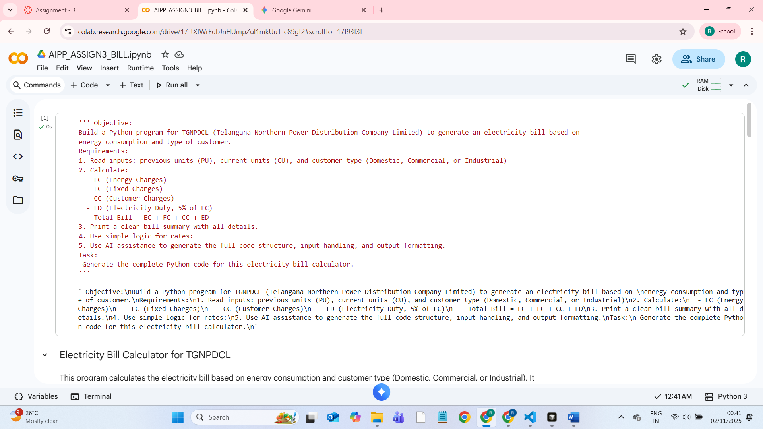
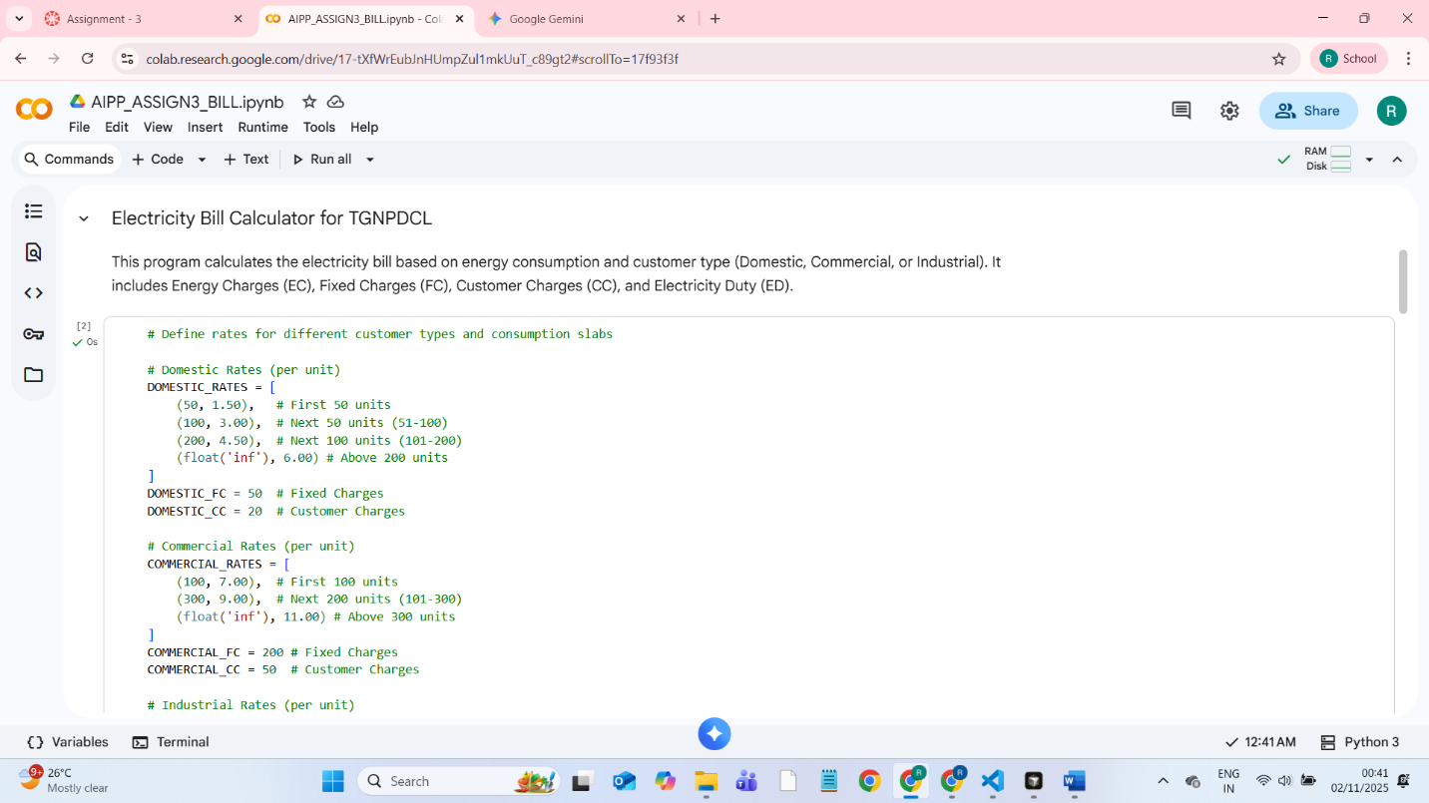
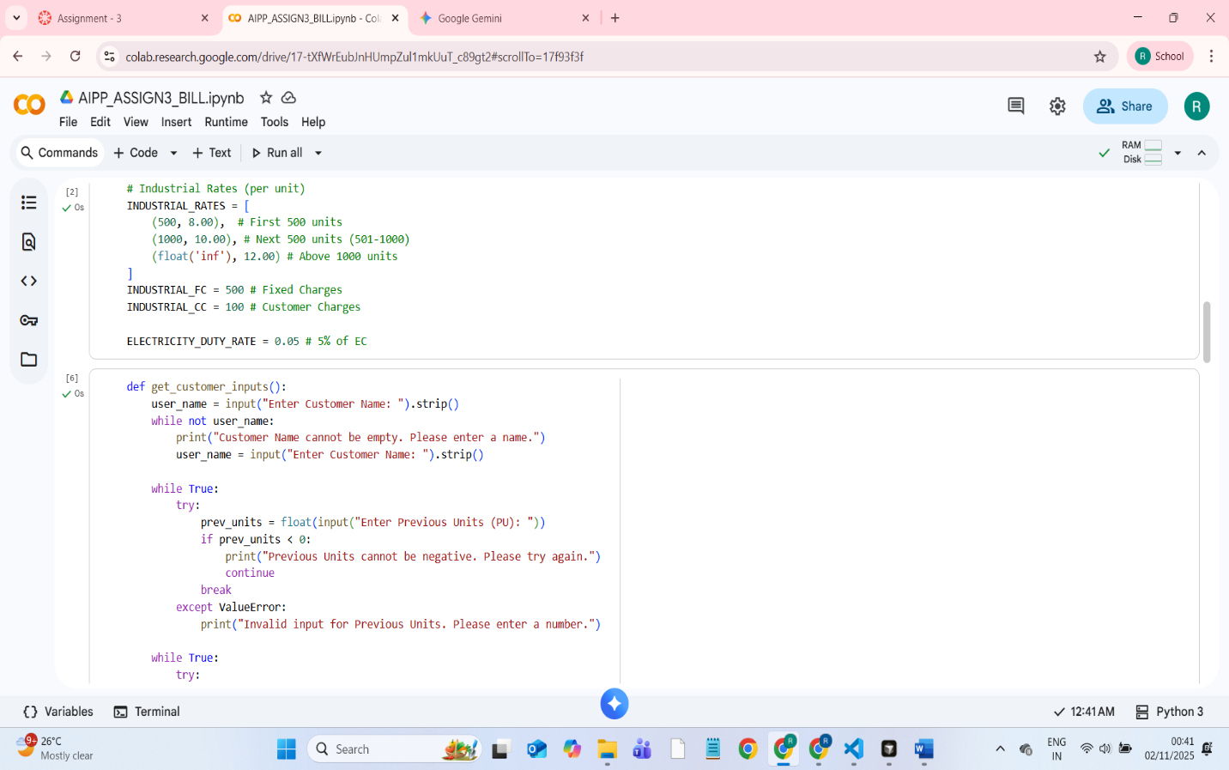
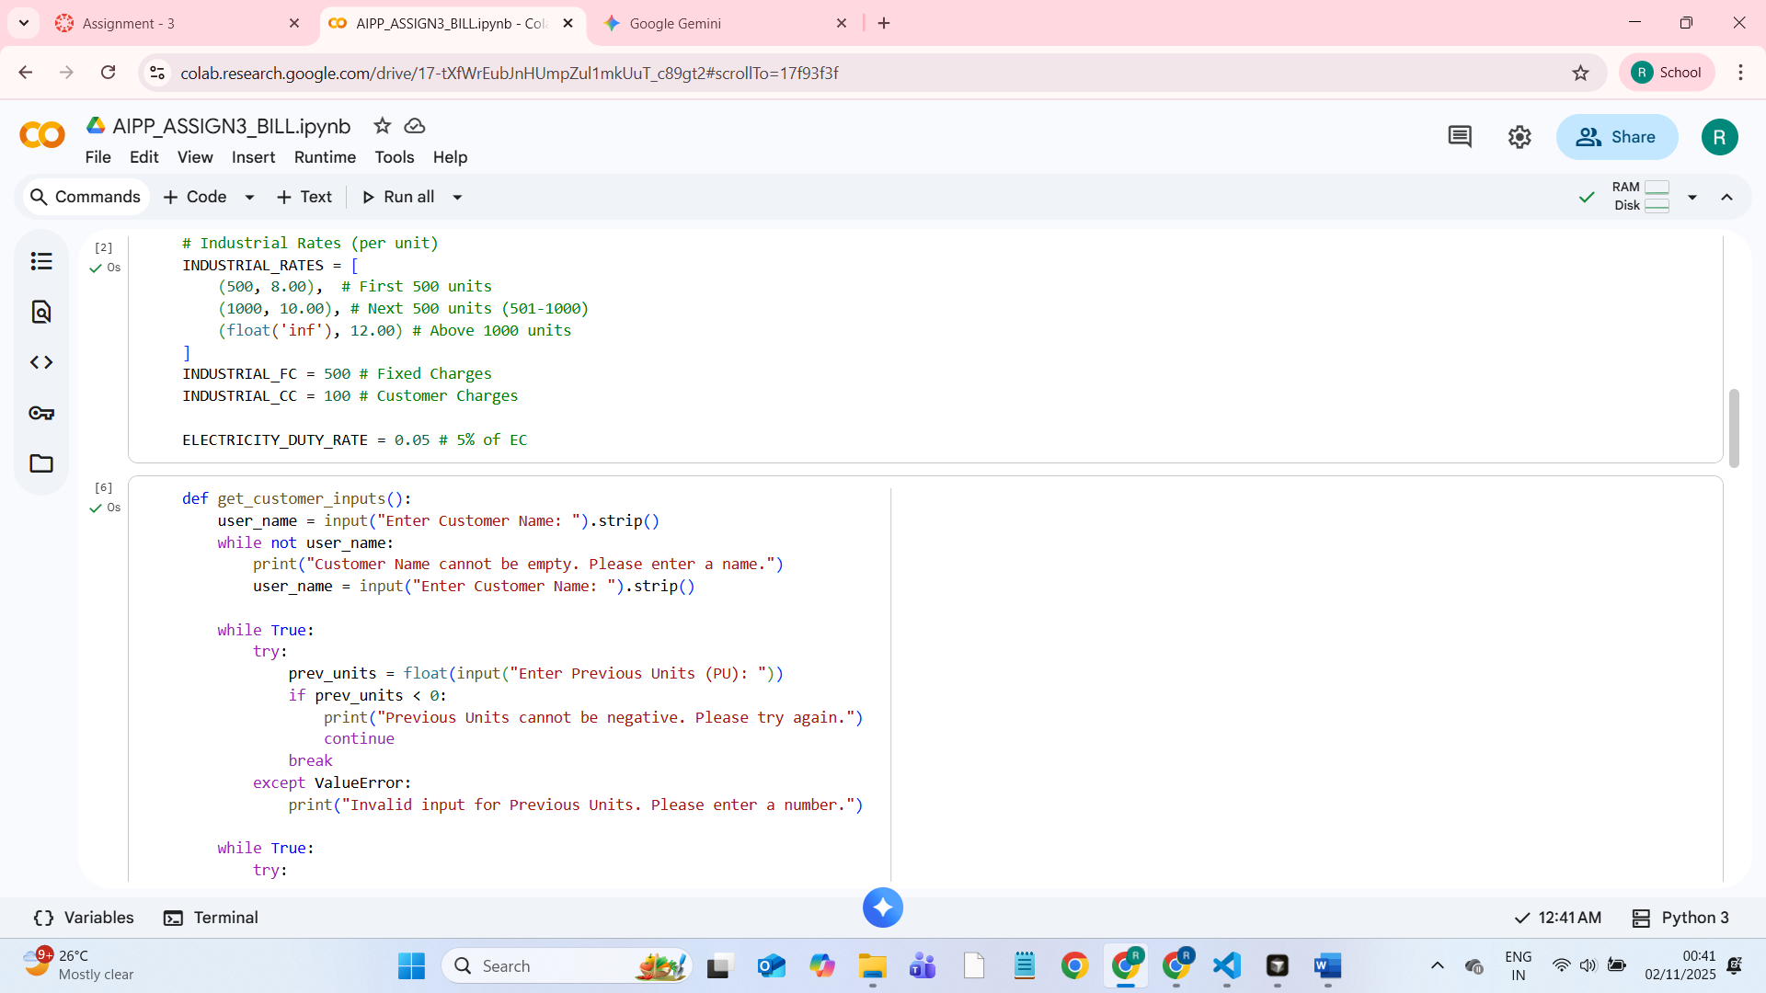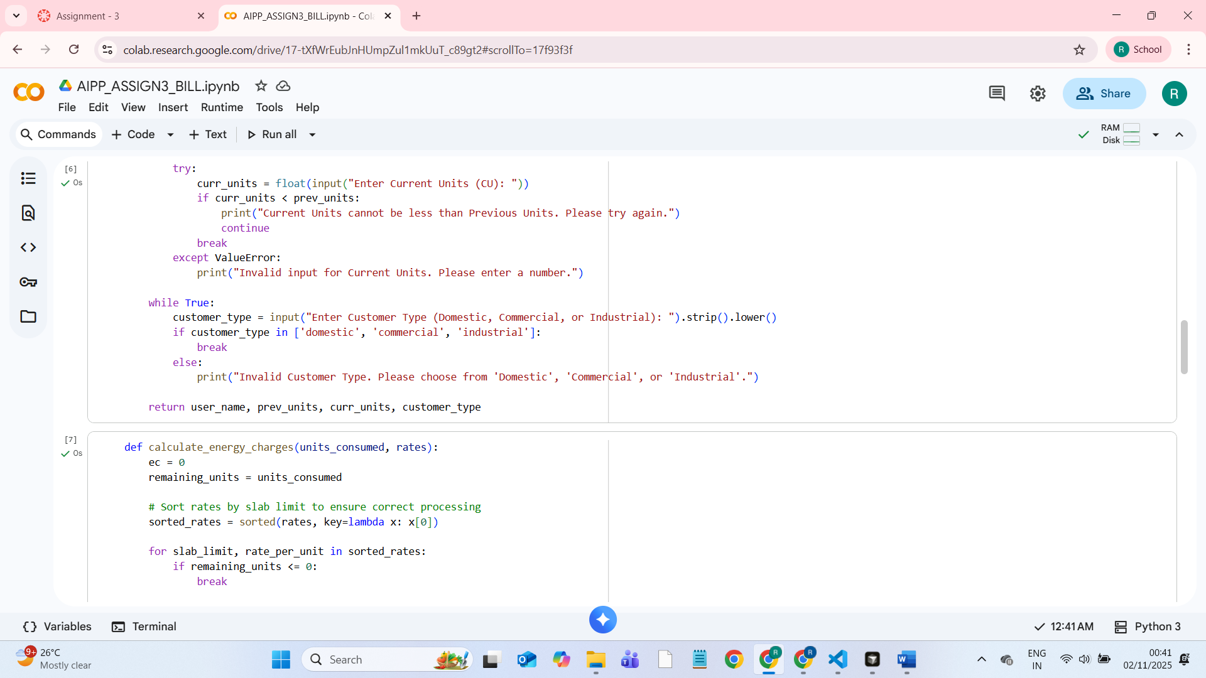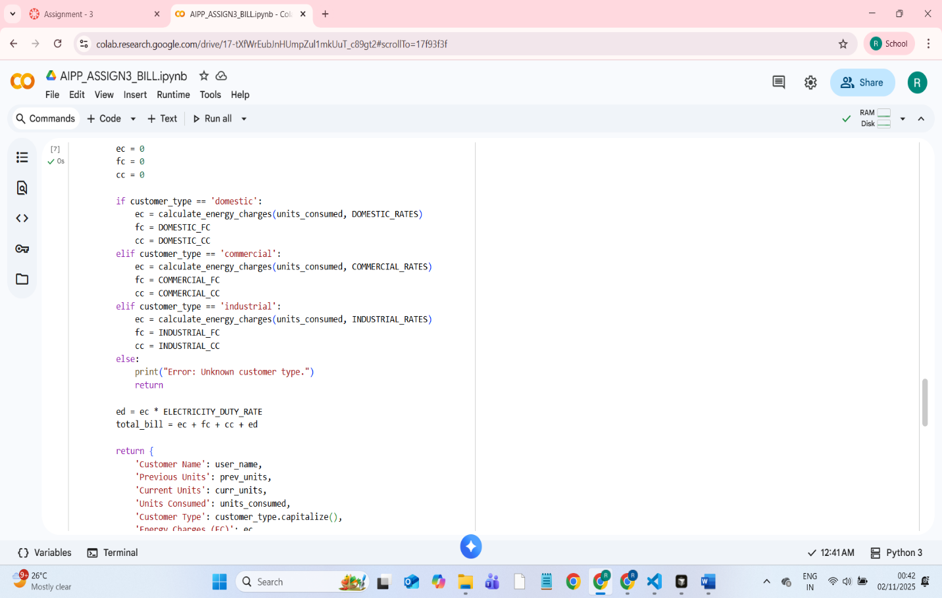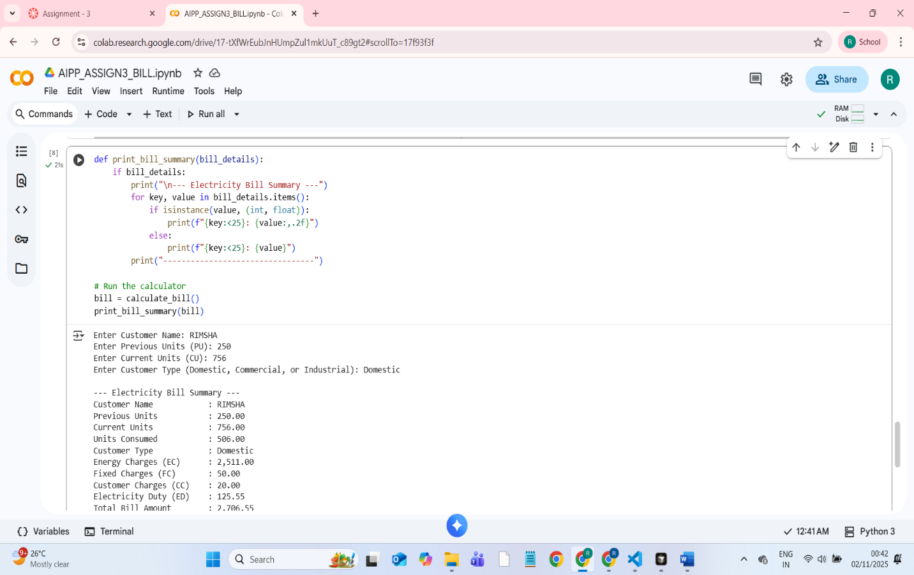

OUTPUT

